Multithreading in Java

**Multithreading in java** is a process of executing multiple threads simultaneously.

Thread is basically a lightweight sub-process, a smallest unit of processing. Multiprocessing and multithreading, both are used to achieve multitasking.

But we use multithreading than multiprocessing because threads share a common memory area. They don't allocate separate memory area so saves memory, and context-switching between the threads takes less time than process.

Java Multithreading is mostly used in games, animation etc.

### Advantages of Java Multithreading

1) It **doesn't block the user** because threads are independent and you can perform multiple operations at same time.

2) You **can perform many operations together so it saves time**.

3) Threads are **independent** so it doesn't affect other threads if exception occur in a single thread.

## Multitasking

Multitasking is a process of executing multiple tasks simultaneously. We use multitasking to utilize the CPU. Multitasking can be achieved by two ways:

* Process-based Multitasking(Multiprocessing)
* Thread-based Multitasking(Multithreading)

### 1) Process-based Multitasking (Multiprocessing)

* Each process have its own address in memory i.e. each process allocates separate memory area.
* Process is heavyweight.
* Cost of communication between the process is high.
* Switching from one process to another require some time for saving and loading registers, memory maps, updating lists etc.

### 2) Thread-based Multitasking (Multithreading)

* Threads share the same address space.
* Thread is lightweight.
* Cost of communication between the thread is low.

#### Note: At least one process is required for each thread.

## What is Thread in java

A thread is a lightweight sub process, a smallest unit of processing. It is a separate path of execution.

Threads are independent, if there occurs exception in one thread, it doesn't affect other threads. It shares a common memory area.

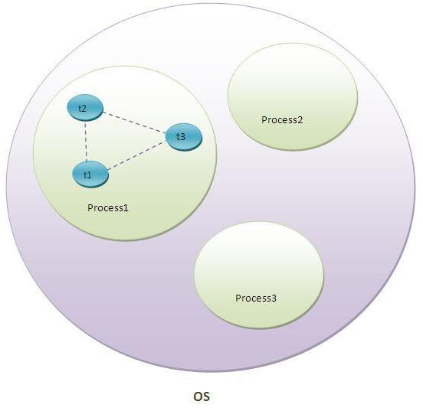

As shown in the above figure, thread is executed inside the process. There is context-switching between the threads. There can be multiple processes inside the OS and one process can have multiple threads.

#### Note: At a time one thread is executed only.

# Life cycle of a Thread (Thread States)

A thread can be in one of the five states. According to sun, there is only 4 states in **thread life cycle in java** new, runnable, non-runnable and terminated. There is no running state.

But for better understanding the threads, we are explaining it in the 5 states.

The life cycle of the thread in java is controlled by JVM. The java thread states are as follows:

1. New
2. Runnable
3. Running
4. Non-Runnable (Blocked)
5. Terminated

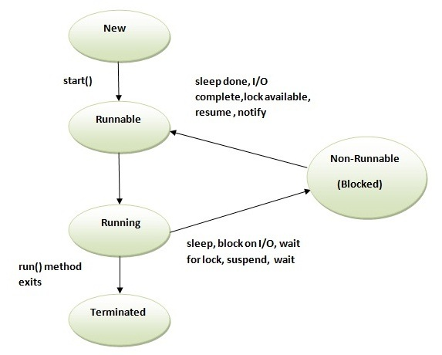

|  |
| --- |
| 1) New The thread is in new state if you create an instance of Thread class but before the invocation of start() method. |

### 2) Runnable

The thread is in runnable state after invocation of start() method, but the thread scheduler has not selected it to be the running thread.

### 3) Running

The thread is in running state if the thread scheduler has selected it.

### 4) Non-Runnable (Blocked)

This is the state when the thread is still alive, but is currently not eligible to run.

### 5) Terminated

A thread is in terminated or dead state when its run() method exits.

How to create thread

There are two ways to create a thread:

1. By extending Thread class
2. By implementing Runnable interface.

### Thread class:

|  |
| --- |
| Thread class provide constructors and methods to create and perform operations on a thread.Thread class extends Object class and implements Runnable interface. |

### Runnable interface:

|  |
| --- |
| The Runnable interface should be implemented by any class whose instances are intended to be executed by a thread. Runnable interface have only one method named run(). |

|  |  |  |
| --- | --- | --- |
| **public void run():**is used to perform action for a thread. Starting a thread:  |  | | --- | | **start() method** of Thread class is used to start a newly created thread. It performs following tasks:   * A new thread starts(with new callstack). * The thread moves from New state to the Runnable state. * When the thread gets a chance to execute, its target run() method will run. | |  | |

# Thread Scheduler in Java

**Thread scheduler** in java is the part of the JVM that decides which thread should run.

There is no guarantee that which runnable thread will be chosen to run by the thread scheduler.

Only one thread at a time can run in a single process.

The thread scheduler mainly uses preemptive or time slicing scheduling to schedule the threads.

### Difference between preemptive scheduling and time slicing

Under preemptive scheduling, the highest priority task executes until it enters the waiting or dead states or a higher priority task comes into existence. Under time slicing, a task executes for a predefined slice of time and then reenters the pool of ready tasks. The scheduler then determines which task should execute next, based on priority and other factors.

# Sleep method in java

The sleep() method of Thread class is used to sleep a thread for the specified amount of time.

## Syntax of sleep() method in java

The Thread class provides two methods for sleeping a thread:

* public static void sleep(long miliseconds)throws InterruptedException
* public static void sleep(long miliseconds, int nanos)throws InterruptedException

# Can we start a thread twice

No. After starting a thread, it can never be started again. If you does so, an IllegalThreadStateException is thrown. In such case, thread will run once but for second time, it will throw exception.

What if we call run() method directly instead start() method?

|  |
| --- |
| * Each thread starts in a separate call stack. * Invoking the run() method from main thread, the run() method goes onto the current call stack rather than at the beginning of a new call stack. |

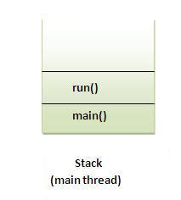

# The join() method

The join() method waits for a thread to die. In other words, it causes the currently running threads to stop executing until the thread it joins with completes its task.

### Syntax:

|  |
| --- |
| public void join()throws InterruptedException |
| public void join(long milliseconds)throws InterruptedException |